Model Training

1. Model Background and Objective
The neural network model is designed to address the padding problem. The input consists of all task arcs, including flight arcs, maintenance arcs, ground arcs, and super arcs. The output is an optimized path, representing the arranged sequence of task arcs.

2. Model Structure
The model is a graph attention model, trained using reinforcement learning. During training, the rollout baseline model is updated by analyzing the model's computed cost, allowing it to generate paths with lower costs. The cost calculation consists of two main components:The total cost of the padding path (cost), which includes the lost connection cost and the illegal connection cost with added penalty factors.；The reinforcement learning loss, calculated using the following formula:
Where bl_val represents the cost of the current path evaluated by the baseline model, and bl_loss is the loss of the baseline model.
Optimization Objective: Optimize the model's log-likelihood to minimize the generated path cost as much as possible.

3. Training Time:11:19:59
Training Log: 194344.out (included in the compressed file).
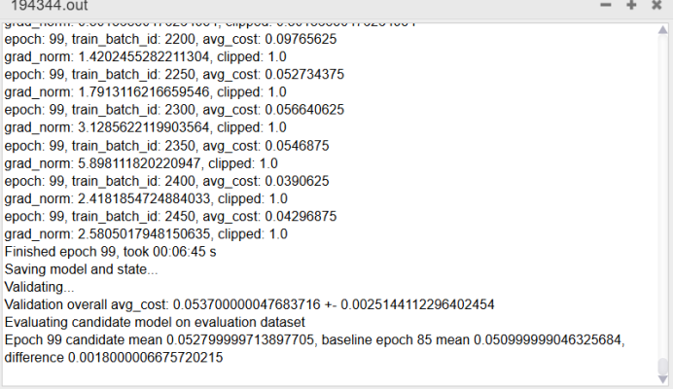
After 100 training iterations, it was observed that at epoch 85, the average path cost was the lowest and passed the p-test, indicating the best model. Therefore, the corresponding .pt file has been extracted (included in the compressed file).

4. Replace the model with a standard neural network and train it to compare its performance with the graph attention model that incorporates an attention mechanism.
We made the following changes to the model:
A. The model replaces the attention layer with a simple feedforward layer. Each encoder layer consists of two fully connected layers and an activation function.
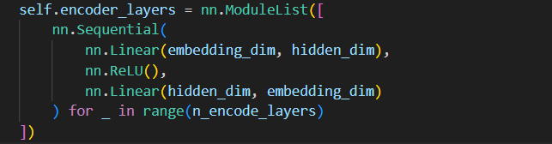
B. The model selects nodes using simple maximum probability or probability distribution instead of generating attention weights for each node through the attention mechanism and selecting nodes via weighted averaging.
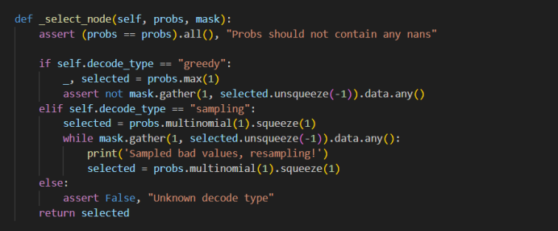

4.1 Training Time:05:13:14
Training Log:196429.out(included in the compressed file).
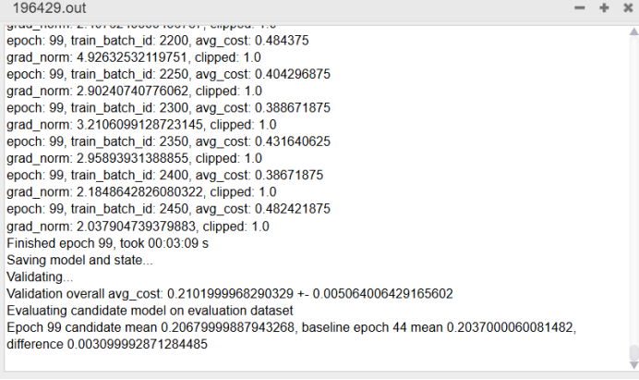
After 100 training iterations, it is observed that at epoch 44, the average path cost is the lowest and passes the statistical test, making it the optimal model. Therefore, the corresponding .pt file is extracted (included in the compressed package).

5. The difference between the two
1. It can be seen that by removing the attention mechanism, the model structure is simplified, and the training time is significantly reduced. One model takes more than 11 hours, while the regular neural network model only takes a little over 5 hours.
2. It can be observed that the average path cost of the attention model is significantly lower than that of the regular neural network model during training. This is because the attention mechanism allocates weights, focusing more on missing and invalid connections, making node selection more precise and allowing the model to find lower-cost paths more quickly.
3.Evaluating both trained models on the same validation set, the graph attention model reached its best performance at epoch 85, achieving an average validation cost of 0.05290000140666962 ± 0.0025280029512941837. In contrast, the standard neural network model reached its best performance at epoch 44, with an average validation cost of 0.20630000531673431 ± 0.005013635847717524. This clearly shows that the standard neural network model incurs a significantly higher average path cost compared to the graph attention model, indicating that the graph attention model outperforms the standard neural network model.
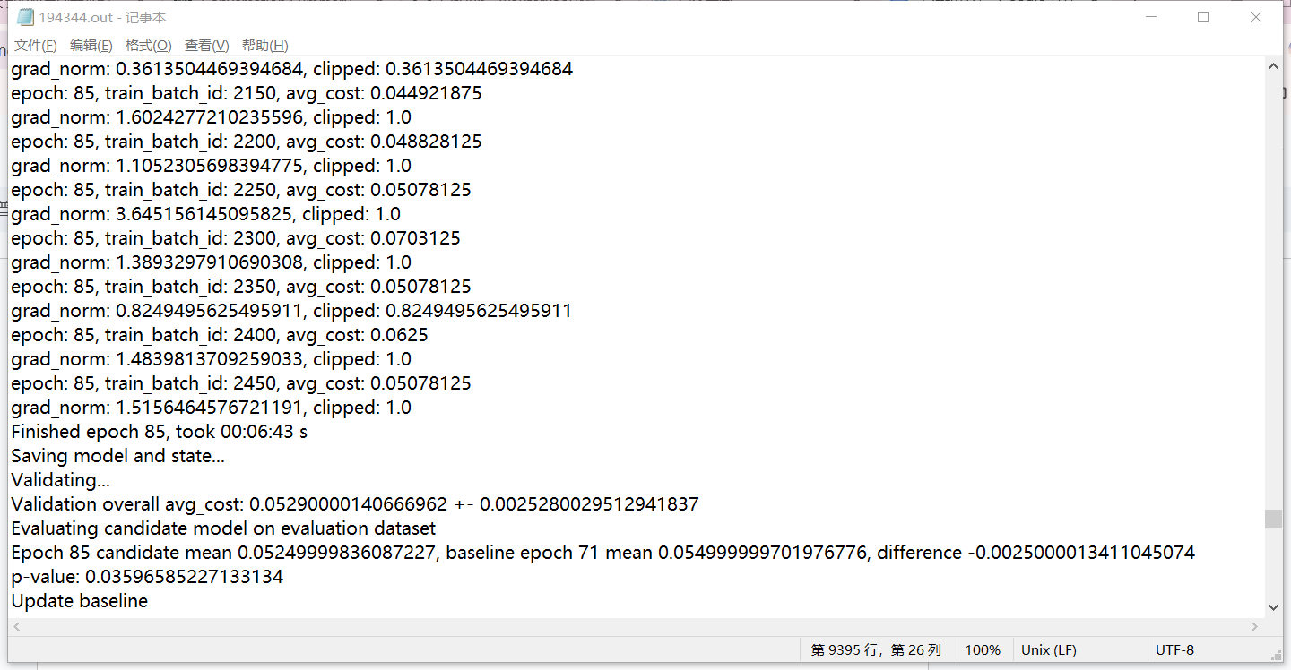
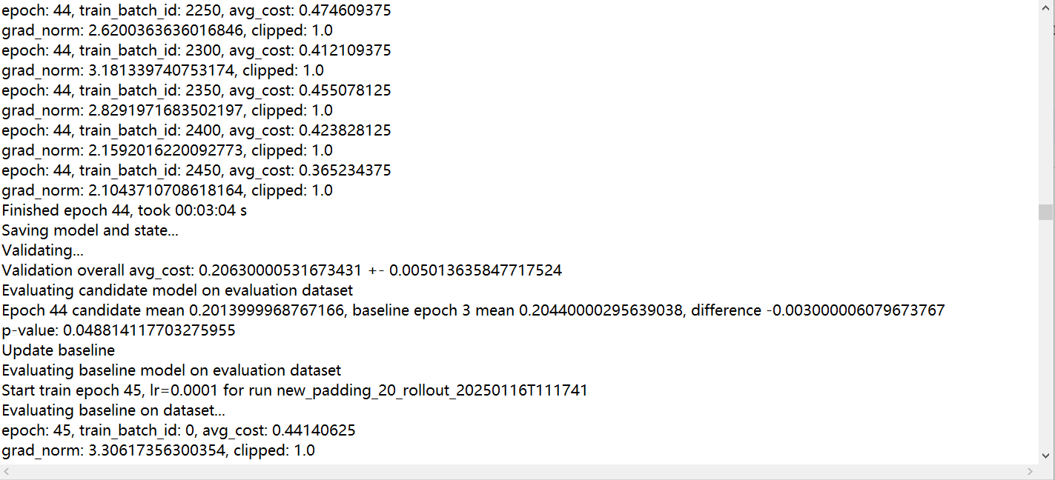

Adding a new feature — priority
The computational cost of the padding problem is to minimize the loss of connections and eliminate illegal connections. The intuitive shielding strategy for the original problem is to only shield those TEPs that create illegal connections in the current iteration. In a given iteration, this short-sighted strategy shields each outbound TEP of some illegal connections, where the inbound TEPs of these illegal connections are located within the current subsequence. However, this short-sighted strategy is ineffective because it only delays rather than eliminates infeasibility. Eventually, all remaining TEPs need to be selected. Therefore, a stronger path subsequence is defined to eliminate this delay. We attempt to transfer this characteristic to the node's own features, aiming to minimize this delay when selecting nodes. We found that delay typically occurs when the outbound tasks corresponding to the current inbound tasks are not promptly included in the path but instead the inbound tasks are continued to be selected, leading to the generation of delay. Thus, when selecting nodes, the probability of choosing outbound tasks should be increased, i.e., the priority of outbound tasks should be raised. Therefore, a priority feature has been added to each node, where the priority feature is related to the time and whether the task is an outbound task.
Specific modifications:
（1）Add new feature priority
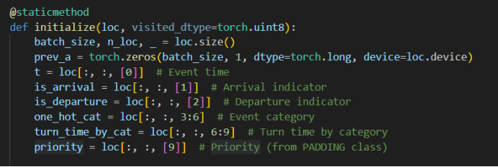
（2）Setting the characteristic value
Setting the feature value Outbound tasks (event_type == 1) have a higher priority.
Inbound tasks (event_type == 0) have a lower priority.
The priority is also related to the event time t. The closer the time is to zero, the higher the priority, because the scheduling is generally based on time.
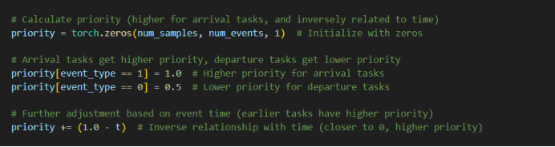
（3）Adding the priority to the cost calculation makes the connection cost of losing the outbound task greater, which increases the probability of the model selecting the outbound task.
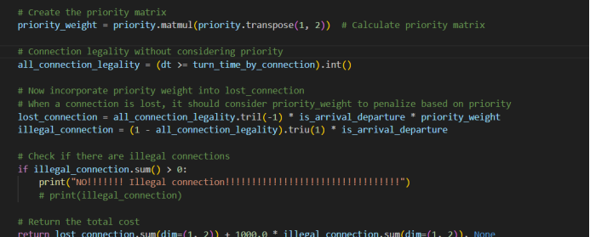
（4）Effect of introducing priorities on lost connections
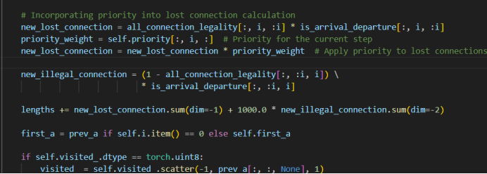
（5）Change the node feature dimension to 10
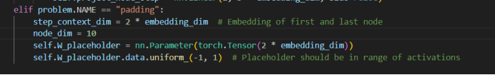
（6）Training log:199162.out
Training time:06:11:47
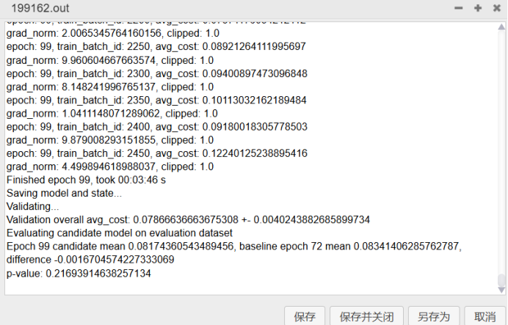
After training one hundred times, it can be seen that when the training cycle is 72, the average path cost is the lowest and passes the t-test, and the model is the best, so take out the pt file (in the compressed package).
(7) The difference with not adding feature priority:
A. It can be seen that adding priority features can greatly reduce training time compared with the need for external judgment.
B. From the above training log, it can be seen that the average path cost of the best model is 0.0834, while the average path cost of the best model without adding it is about 0.051, which is slightly higher. In the future, the gap with it can be further reduced by adjusting the initial value of the priority of the inbound and outbound tasks and the function related to time.

Is there any illegal connection?
How the code handles illegal connections
(1) First determine whether there is an illegal connection

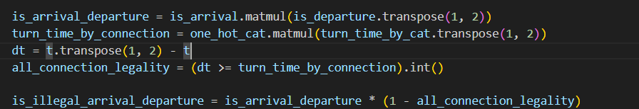
(2) If there is an illegal connection, the position of the node will be adjusted to avoid illegal connection; if there are multiple illegal connections, the node that causes the largest illegal connection event will be selected for adjustment.
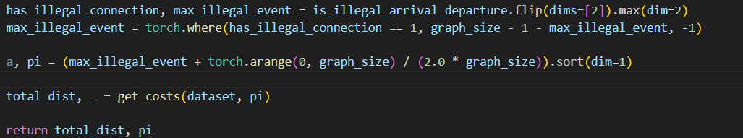
By adding the judgment function, it is found that there are indeed multiple illegal connections.

(3) How to greatly reduce illegal connections? The first is that since the sampling method is sampling, there will be many sequences in an instance. Each sequence will be adjusted once to obtain the final cost, and the lowest cost of these sequences will be selected as the final cost of the sample instance. The second is to increase the penalty factor so that the model can select nodes that do not cause illegal connections as much as possible during training.
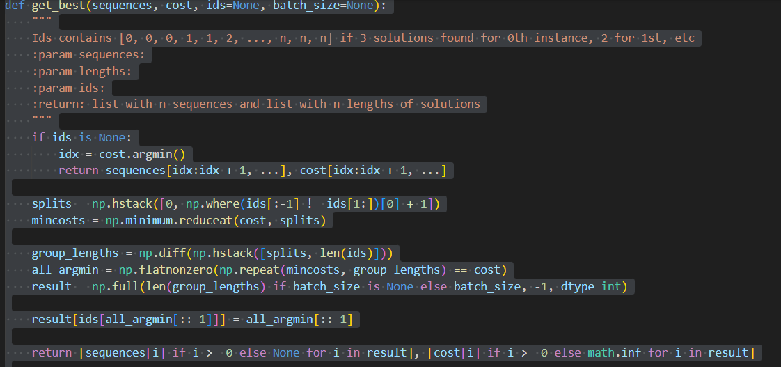

padding问题算法框架图

1.padding_solution
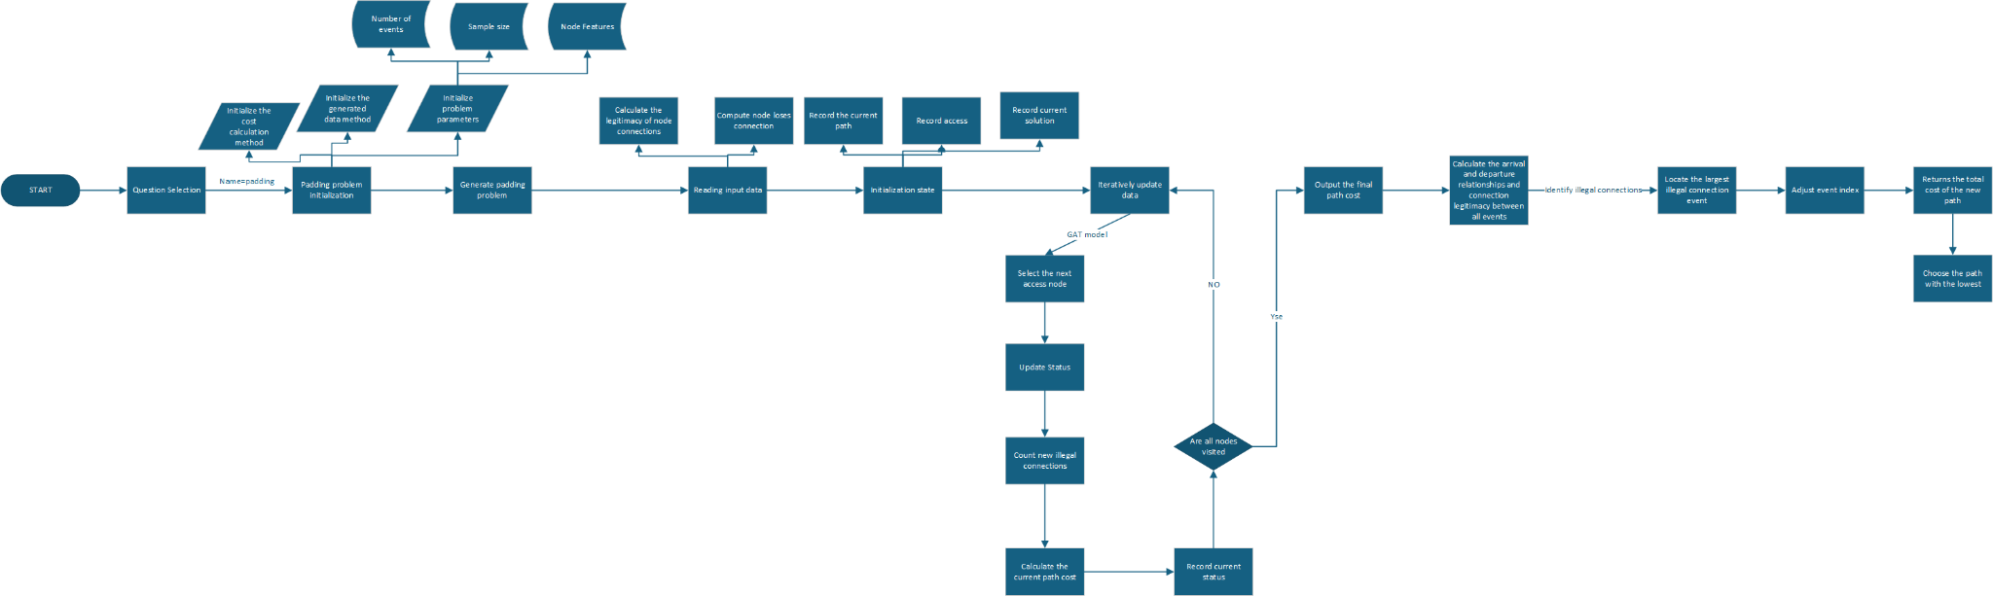

2.Running and training of the padding model
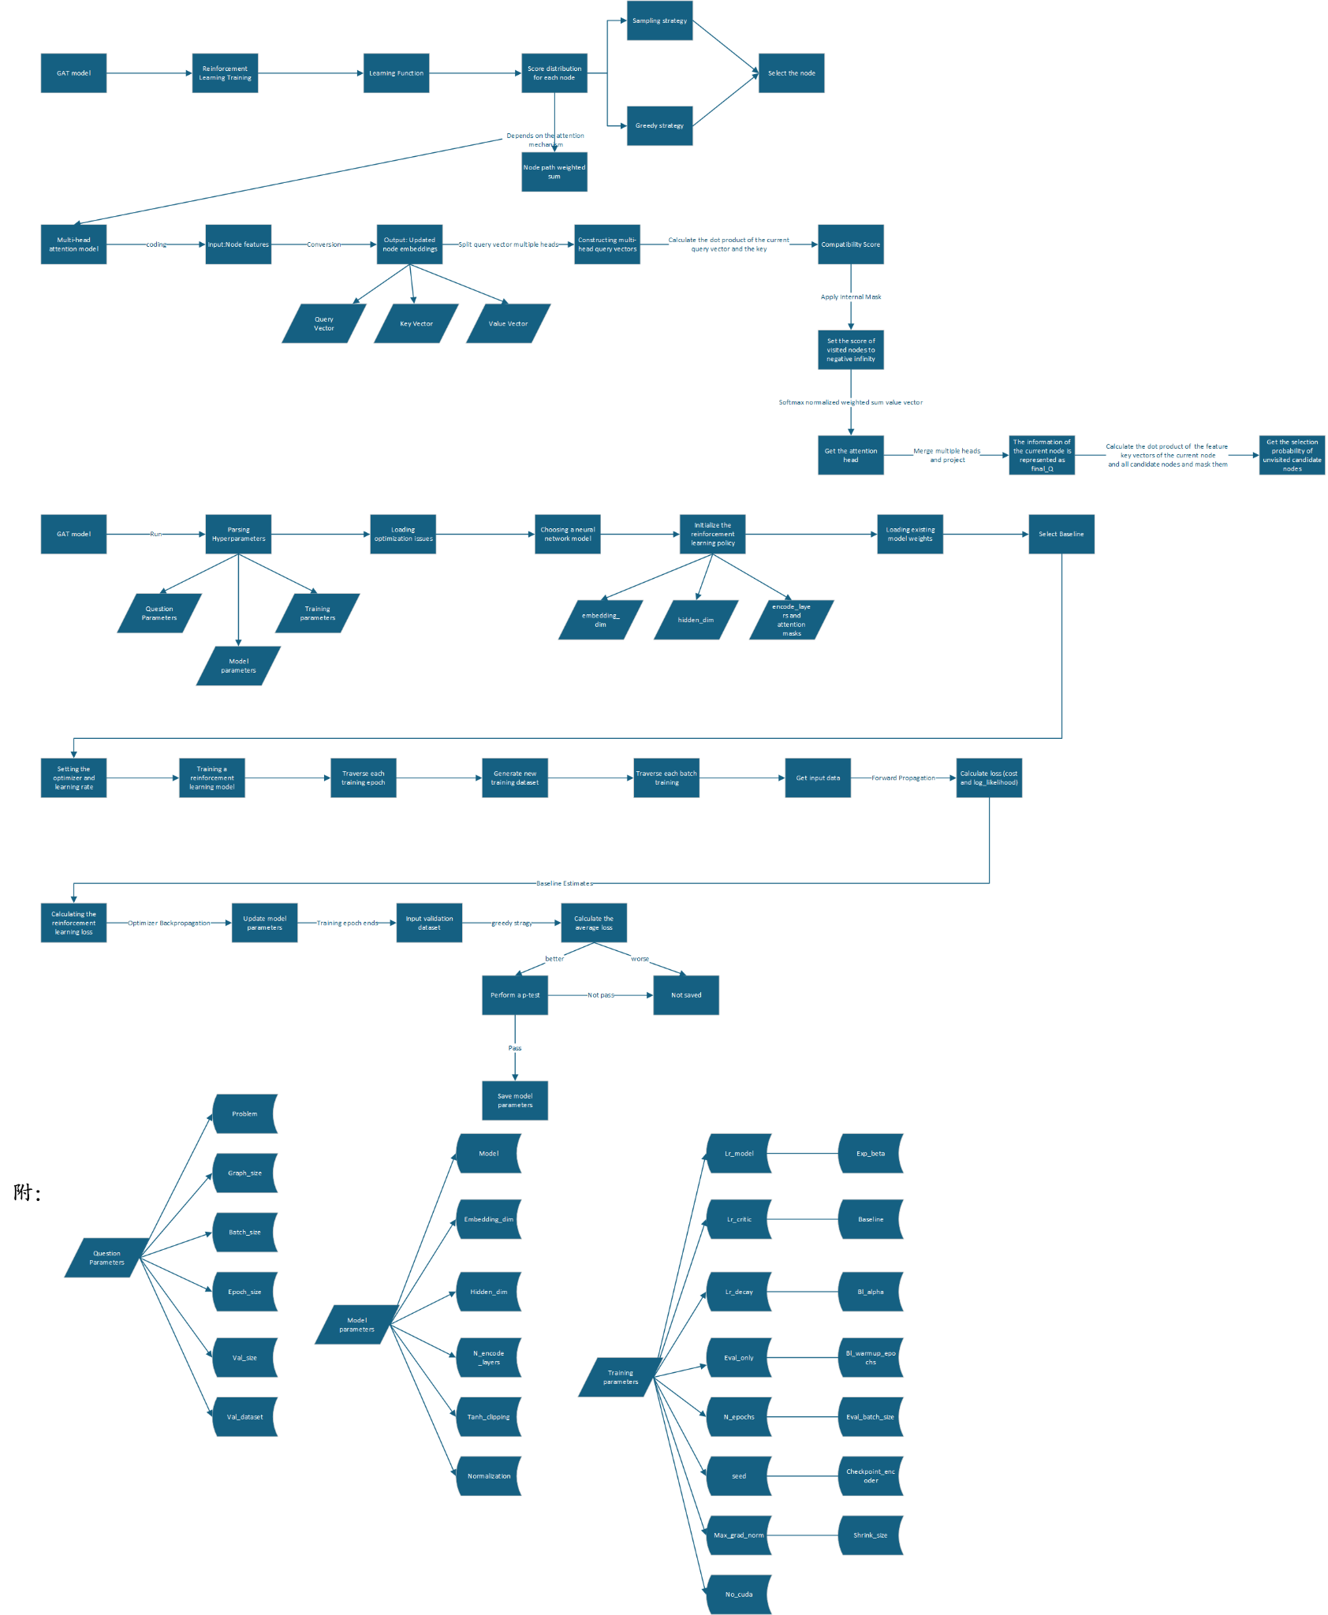

Padding check

1. Purpose:
The validation set for the training model is no longer generated randomly, but is generated with restrictions, so that the event sorting path has only a few legal paths, and most paths have illegal connections, to check whether the model can find legal paths.

2. Data generation method:
The generate_padding_data function is used to generate an event dataset that is strictly sorted in ascending time order, where each data instance contains 10 pairs of mandatory consecutive events (i.e., "arrival event" and the "departure event" that follows it), and the total number of events is fixed to event_size (e.g., 50 events) by padding or truncating.
Each event consists of the following features:
1. Timestamp: Indicates the time when the event occurred, and all events are sorted in ascending time.
2. Event type: One-hot encoding is used, [1.0, 0.0] represents "arrival event", and [0.0, 1.0] represents "departure event".
3. Category information: One-hot encoding is also used, with a total of 3 categories (category 0, 1, 2).
4. Transition time: Only applicable to arrival events, indicating the transition time of events of this category, while the transition time of departure events is always set to 0.0.
The data generation process is as follows:
1. Generate 10 pairs of forced continuous events:

1.1 Randomly select event categories (0, 1, 2).

1.2 Set the current time current_time, first generate an arrival event, whose time is current_time, and randomly assign a transition time turn_time.

1.3 Then generate the corresponding departure event, whose time must be strictly greater than the arrival event, set to arrival_time + turn_time + 1e-5 to ensure that the time is monotonically increasing.

1.4 Update current_time and randomly leave a certain time interval to generate the next pair of events.

2. Generate 30 free events:

2.1 After current_time, use torch.linspace() to uniformly sample 5 candidate time points in the remaining time window (e.g. [current_time, 100]), and randomly select 30 events from them.

2.2 Each event is randomly determined to be an "arrival event" or a "departure event".

2.3 Event categories are randomly assigned to 0, 1, or 2.
2.4 If it is an arrival event, randomly generate a transition time; the transition time of the departure event remains at 0.0.
3. Merge and sort:

3.1 Combine the forced continuous event and the free event into a complete data instance.
3.2 Sort by timestamp in ascending order to ensure that the event time is strictly increasing.
4. Adjust the number of events:

4.1 If the total number of events exceeds event_size (such as 50), intercept the first event_size events.
4.2 If the total number of events is less than event_size, add random events to ensure that the data length is fixed:
Randomly generate timestamps and insert events of random types and categories.
Reorder to ensure that the time order remains unchanged.

Data generation code：
import argparse
import os
import numpy as np
from utils.data_utils import check_extension, save_dataset
import torch
import pickle

def generate_padding_data(dataset_size, event_size, seed=None):

torch.manual_seed(seed) if seed is not None else None

n_cat = 3
time_window_length = 100
max_turn_time = 10
dataset = []

for _ in range(dataset_size):
# 生成10个强制连续事件对（每个事件对必须连续出现）
mandatory_pairs = []
current_time = 0.0

for _ in range(10):
# 生成事件对的时间参数
cat = torch.randint(n_cat, (1,)).item()
turn_time = torch.rand(1).item() * max_turn_time
pair_duration = turn_time + torch.rand(1).item() * 5 # 总持续时间

# 到达事件
arrival_event = [
current_time,
1.0, 0.0, # 到达事件类型
float(cat == 0), float(cat == 1), float(cat == 2),
turn_time, 0.0, 0.0 # 只有对应类别的转场时间有效
]

# 出发事件（时间严格在到达事件之后）
departure_time = current_time + turn_time + 1e-5 # 确保时间严格递增
departure_event = [
departure_time,
0.0, 1.0, # 出发事件类型
float(cat == 0), float(cat == 1), float(cat == 2),
0.0, 0.0, 0.0 # 出发事件不需要转场时间
]

mandatory_pairs.extend([arrival_event, departure_event])
current_time = departure_time + torch.rand(1).item() * 5 # 为下一个事件对留出时间间隔

# 生成剩余的自由事件（30个）
free_events = []
time_slots = torch.linspace(current_time, time_window_length, 30 + 1)[:-1]
for t in time_slots:
is_arrival = torch.rand(1).item() > 0.5
cat = torch.randint(n_cat, (1,)).item()

free_events.append([
t.item(),
float(is_arrival), float(not is_arrival),
float(cat == 0), float(cat == 1), float(cat == 2),
torch.rand(1).item() * max_turn_time if is_arrival else 0.0,
torch.rand(1).item() * max_turn_time if is_arrival else 0.0,
torch.rand(1).item() * max_turn_time if is_arrival else 0.0
])

# 合并所有事件并按时间排序
all_events = mandatory_pairs + free_events
# 按时间升序排序
all_events.sort(key=lambda x: x [0])

# 截断或填充事件数量至20个
if len(all_events) > event_size:
all_events = all_events[:event_size]
else:
while len(all_events) < event_size:
# 补充随机事件
event_time = torch.rand(1).item() * time_window_length
is_arrival = torch.rand(1).item() > 0.5
cat = torch.randint(n_cat, (1,)).item()
all_events.append([
event_time,
float(is_arrival), float(not is_arrival),
float(cat == 0), float(cat == 1), float(cat == 2),
torch.rand(1).item() * max_turn_time if is_arrival else 0.0,
torch.rand(1).item() * max_turn_time if is_arrival else 0.0,
torch.rand(1).item() * max_turn_time if is_arrival else 0.0
])
all_events.sort(key=lambda x: x [0])

dataset.append(all_events)

return torch.tensor(dataset, dtype=torch.float32).tolist()

def save_dataset(dataset, filename):
"""保存数据集到指定路径"""
filedir = os.path.split(filename) [0]
if not os.path.isdir(filedir):
os.makedirs(filedir, exist_ok=True)

with open(check_extension(filename), 'wb') as f:
pickle.dump(dataset, f, pickle.HIGHEST_PROTOCOL)

if __name__ == "__main__":

dataset = generate_padding_data(
dataset_size=1000,
event_size=50,
seed=1234
)

# 保存到指定路径
save_dataset(dataset, "./data/padding/padding_50_seed1234_1.pkl")
print(dataset[0])

3. Train the model and verify it on the above validation set:
Training log:288691.out
From the training log, we can see that:
In the early stage of the training cycle, the average cost of the validation set is generally maintained above 200, indicating that many illegal paths are generated. After 80 cycles of training, the average cost begins to slowly decrease. After 100 cycles of training, we can see that the average cost is 8.644000053405762 +- 0.07367966324090958, and the legal path is basically found.
